

Whats Is Elevator or Lifts?
Elevator or lifts a type of vertical that moves people or goods between floors (levels,decks) of a building, vessel, or other structure. Elevators are generally powered by electric motors that either drive traction cables or counterweight systems like a hoist, or pump hydraulic fluid to raise a cylindrical piston like a jack.
In agriculture and manufacturing, an elevator is any type of conveyor device used to lift materials in a continuous stream into bins or silos. Several types exist, such as the chain and bucket bucket elevator, grain auger screw conveyor using the principle of Archimedes' screw, or the chain and paddles or forks of hay elevators.
Elevator lobby at the Forest Glen Washington Metro station in Silver Spring, Maryland because of wheelchair access laws, elevators are often a legal requirement in new multistory buildings, especially where wheelchair ramps would be impractical.

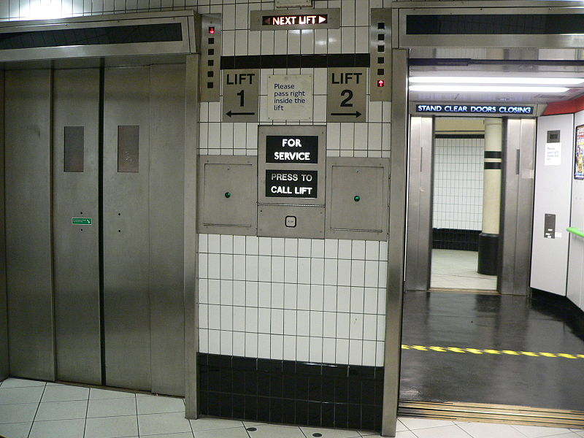
Fig. Elevator or Lift

Elevator Types
- According to hoist mechanism.
- According to building height.
- According to building type.
1- According to hoist mechanism:

Elevators will be classified according to hoist mechanism to 4 main types as follows:
- Hydraulic Elevators
- Traction Elevators
- Climbing elevator

1- Hydraulic Elevators (Push Elevators)

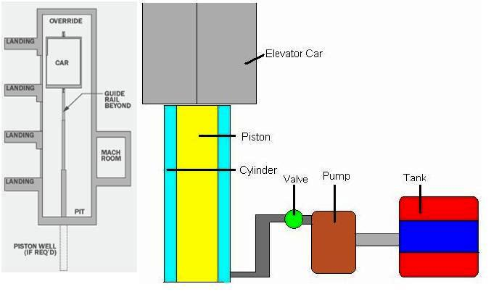
Fig. Hydraulic Elevator
Hydraulic elevators are supported by a piston at the bottom of the elevator that pushes the elevator up. They are used for low-rise applications of 2-8 stories and travel at a maximum speed of 200 feet per minute. The machine room for hydraulic elevators is located at the lowest level adjacent to the elevator shaft.
2- Traction Elevators (Pull Elevators)
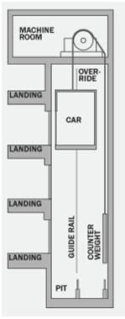

Fig. Transaction Elevators

Traction elevators are lifted by ropes, which pass over a wheel attached to an electric motor above the elevator shaft. They are used for mid and high-rise applications and have much higher travel speeds than hydraulic elevators. A counter weight makes the elevators more efficient.

3- Climbing elevator
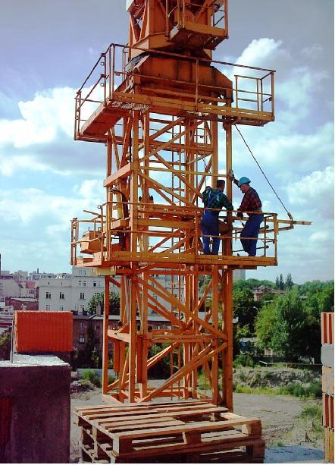
\ Fig Climbing Elevator
They hold their own power device on them, mostly electric or combustion engine. Climbing elevators are often used in work and construction areas.

2- According to building height
A- Low-Rise buildings (1- 3 stories)
Buildings up to about (1 to 3) stories typically use hydraulic elevators because of their lower initial cost
B- Mid-Rise buildings (4 -11 stories)
Buildings up to about (4 to 11) stories typically use Geared Traction Elevators
C- High-Rise buildings (12 + stories)
Buildings up to about 12+ stories typically use Gear-Less Traction Elevators
3- According to building type
Elevators will be classified according to building type to 6 main types as follows:
- Hospital Elevators.
- Residential /Domestic Elevators.
- Agricultural Elevators.
- Industrial Elevators.
1- Hospital Elevators
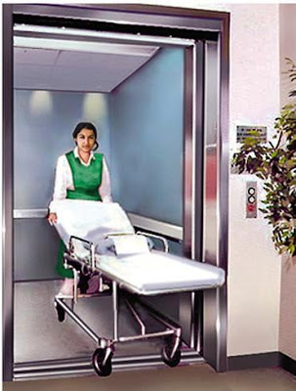
Fig. Hospital Elevator

Hospital bed elevators generally transport patients who are not well enough to sit up
even in a wheelchair. One of the features of bed elevators should be its ability to transport the patient has smoothly as possible with minimal amount of bumping and jostling. Many
contemporary bed elevators are manufactured to consume extremely low amounts of power and to be durable with a number of safety features built-in.

2- Residential /Domestic Elevators
They are usually just on a much smaller scale than industrial or commercial elevators.
3- Agricultural applications:
Bucket elevators are sometimes referred to as conveyor buckets, most often when the movement is horizontal or on an incline. However, technically speaking, vertical movement is also accomplished with a conveyor belt or chain. The centrifugal discharge bucket elevator is perhaps the most common type. Of course, as the name implies the elevator is driven by centrifugal force.

4- Industrial Elevators
The most common types of industrial elevators are hoist elevators and incline elevators. These types of elevators are built to carry huge amounts of weight effortlessly, therefore the term industrial elevators. This type of elevators is used in construction, warehouses, and shipyards.

Components Of Elevators:
The standard elevators will include the following basic components:
- Car.
- Hoist way.
- Machine/drive system.
- Control system.
- Safety system.

First Car type:
Elevator Car is the vehicle that travels between the different elevator stops carrying passengers and/or goods, it is usually A heavy steel frame surrounding a cage of metal and wood panels.
Elevator Car Types:
Standard elevator car/cabin can be classified according to the number of entrances and their locations as follows:
- Normal Cabin
- Open Through Cabin
- Diagonal Cabin

Second Hoistway

Hoistway is the space enclosed by fireproof walls and elevator doors for the travel of one or more elevators, dumbwaiters or material lifts. It includes the pit and terminates at the underside of the overhead machinery space floor or grating or at the underside of the roof where the hoistway does not penetrate the roof. (Hoistway is sometimes called "hatchway" or "hatch".

A simple definition for the hoistway is the shaft that encompasses the elevator car.
Note: Generally the Hoistway serving all floors of the building but in high-rise buildings hoistways may be banked with specific hoistways serving only the lower floors and others serving only middle or upper floors while traveling in a blind hoistway until reaching the floors that it serves. A blind hoistway has no doors on the floors that it does not serve.
Third: Elevator Machine and drive system
Driving machine, this is the power unit of the elevator, and usually located at the elevator machine room.
The Driving machine used to refer to the collection of components that raise or lower the elevator. These include the drive motor, brake, speed reduction unit, sheaves and encoders.

Forth: Safety system:

Layout of Elevator Safety System
The following list describes all the safety components used in electrical traction elevator safety system:
- Device for locking landing doors (Hoistway Door Interlock).
- Progressive safety gear.
- Overspeed governor.

- Buffers.
- Final Limit switches.
- Other safety devices and switches.

Fifth: Elevator Control System
Elevator Control System is the system responsible for coordinating all aspects of elevator service such as travel, speed, and accelerating, decelerating, door opening speed and delay, leveling and hall lantern signals.
It accepts inputs (e.g. button signals) and produces outputs (elevator cars moving, doors opening, etc.).

Aims of the control system
The main aims of the elevator control system are:
- To bring the lift car to the correct floor.
- To minimize travel time.
- To maximize passenger comfort by providing a smooth ride.

